OWENSVILLE POLICE DEPARTMENT
OWENSVILLE, MO
(573) 437-2195
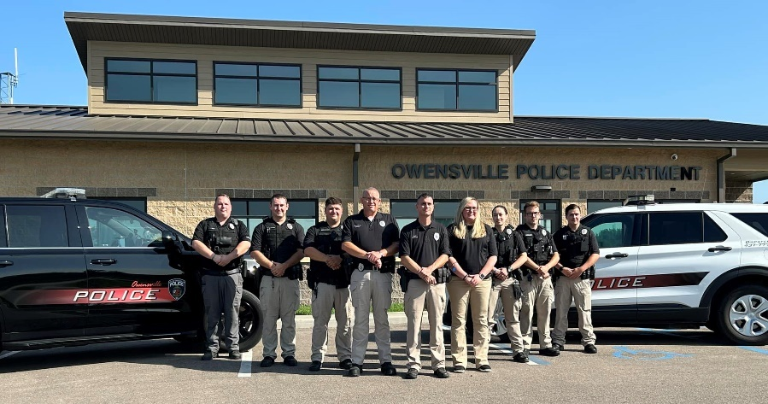
Now Hiring: FULL-TIME POLICE OFFICER
Minimum Starting Pay: $20.91/hour
15 step pay scale maxing out at $28.14/hour
Plus paid overtime & 13 paid holidays

Qualifications: Must be 21 years of age, have a current Missouri POST commission, have a high school diploma or GED equivalent, be a valid U.S. citizen, and possess a valid driver’s license.
Benefits: Health, life, vision and dental insurance for the employee and their families. City pays 100% health insurance for employee & 75% for spouses and children. The city is also enrolled in the L-6 LAGERS retirement plan, and offers additional optional benefits. Officers’ duty gear and uniforms are paid for by City and Officers also receive an annual uniform allowance.
Scheduling: Normal schedule is seven 12-hour shifts in a 2-week cycle with every other weekend off.
Other Incentives: After the first year of employment, employees will have 40 sick, 40 personal, and 40 vacation hours which is received annually. Employees will then receive an additional 40 hours of vacation after completing 2, 5, 10, and 15 years of employment. Sick & personal time can roll over each year and vacation can be used or paid out.

OPD is a department of 8 full time officers & also has a reserve/part-time program. OPD actively participates in the community and hosts community events. OPD has a newly built Police Department, is acquiring new equipment, and has a vehicle fleet that includes new patrol vehicles.

OPD is currently looking to add an additional officer to our team. If you are interested, please contact
Chief Scott Griffith (#573-619-0357) or contact the Police Department at police@cityofowensville.com.

Position will remain open until filled.
The City of Owensville is an Equal Opportunity Employer.

